PUBLISH DATA TO THE IBM CLOUD

|  |  |
| --- | --- |
| Date | 14 November 2022 |
| Team ID | PNT2022TMID42038 |
| Project Name | Project – IOT Based Real – time RiverWater Quality Monitoring and Control  System |
| Maximum Marks | 4 Marks |

You can publish your virtual data to catalogs in Watson™ Knowledge Catalog. An administrator can configure Data Virtualization to automatically publish all virtual objects that are created in the user interface to a configured primary catalog.

By publishing your virtual data to a catalog, you can:

*Organize, label, classify, and search for the published data assets with global search.

*Govern the virtual data asset and subject it to data protection rules by [enabling HYPERLINK](https://www.ibm.com/docs/en/SSQNUZ_4.5.x/svc-dv/enable-strict.html) ["https://www.ibm.com/docs/en/SSQNUZ_4.5.x/svc-dv/enable-](https://www.ibm.com/docs/en/SSQNUZ_4.5.x/svc-dv/enable-strict.html) [strict.html"policyenforcement HYPERLINK](https://www.ibm.com/docs/en/SSQNUZ_4.5.x/svc-dv/enable-strict.html) ["https://www.ibm.com/docs/en/SSQNUZ_4.5.x/svc-dv/enable-](https://www.ibm.com/docs/en/SSQNUZ_4.5.x/svc-dv/enable-strict.html) [strict.html" HYPERLINK](https://www.ibm.com/docs/en/SSQNUZ_4.5.x/svc-dv/enable-strict.html) ["https://www.ibm.com/docs/en/SSQNUZ_4.5.x/svc-dv/enable-](https://www.ibm.com/docs/en/SSQNUZ_4.5.x/svc-dv/enable-strict.html) [strict.html"i](https://www.ibm.com/docs/en/SSQNUZ_4.5.x/svc-dv/enable-strict.html)n Data

*Navigate to **Service settings**.

*On the **Governance** tab, enable the **Enforce publishing to a governed catalog** option. A list of governed catalogs that you have Admin access to is shown. You must select a governed catalog asyour primary catalog. When you set a primary catalog, all

virtualized objects are published to this catalog automatically. The **Publish to catalog**

option is disabled when you review your cart and virtualize tables.

* On the service menu, click **Virtualization** > **Virtualized data**.
* Select the virtual objects that you want to publish and click **Publishto catalog**.

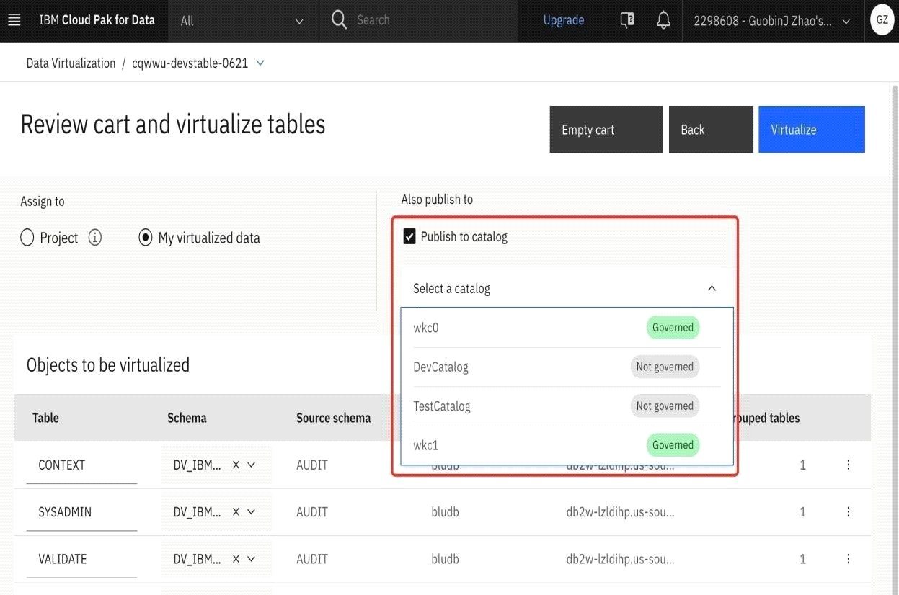

* Continue with the virtualization process